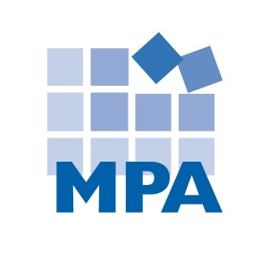
Compliance Client News – Mach 14, 2022
This newsletter summarizes compliance and HIPAA news from February 2022.

OIG Enforcement

- OIG Settlements

In February 2022, there were 33 OIG health care fraud enforcement cases. The 33 cases involved:

- Fraud/False Claims: 26
- Criminal Charges: 16
- Kickbacks/Stark: 10
- Doctors: 9
- Medical Necessity: 9
- Hospitals/Health Systems: 7
- The Civil Monetary Penalties Law: 6
- Enforcement Against Owners/Executives: 6
- Opioids and Other Drugs: 6
- Self-Disclosure: 6
- DME: 5
- False Statements/Records: 5
- Excluded Providers: 4
- Compounded Medications: 3
- Pharmacies: 3
- Whistleblowers: 3
- Beneficiary Inducements: 2
- Copay Waivers: 2
- Home Health: 2
- Nurse Practitioners: 2
- Pain Management: 2
- Prescriptions: 2
- Telemedicine: 2

There was one example of each of the following: the Controlled Substances Act; diabetic supplies; a diagnostic testing company; genetic tests; a health plan; a lab; a medical director; a Medicare reimbursement consultant; a mental health counselor; a naturopathic doctor; overpayments; a pharmacy; a physician practice; a psychiatric practice; a psychologist; selling medical information; unlicensed practitioner; and urine drug tests.

- False Claims/Health Care Fraud

- Untimely overpayments. A hospital self-disclosed that it failed to timely return overpayments to Medicare and New Hampshire Medicaid. The hospital agreed to pay a $10,000 Civil Monetary Penalty. https://oig.hhs.gov/fraud/enforcement/new-london-hospital-association-agreed-to-pay-10000-for-allegedly-violating-the-civil-monetary-penalties-law-by-retaining-medicare-and-medicaid-overpayments/

- Services provided by unlicensed therapists. A mental health counselor entered a $135,000 settlement to resolve fraudulent Medicaid billing accusations. The counselor is accused of billing Medicaid “for unlicensed and unqualified therapists who did not meet qualification requirements, were not contracted with the state, and were not eligible for reimbursement through Medicaid.” The counselor also allegedly falsely misrepresented that the services were provided by qualified/licensed individuals. This case was brought by a whistleblower. https://oig.hhs.gov/fraud/enforcement/spokane-mental-health-counselor-agrees-to-pay-more-than-135000-for-fraudulent-medicaid-billing/

- Surgeon billed for unnecessary services. A vascular surgeon pleaded guilty of defrauding Medicare, Medicaid, and Blue Cross Blue Shield of $19.5 million. The doctor “billed for the placement of multiple stents in the same vessel, and prepared medical records purporting to document the medical necessity justifying that billing. In fact, [he] did not place those stents, and he admitted to billing the insurers for services never rendered while preparing materially inaccurate medical records to justify the fraudulent billing.” https://www.justice.gov/usao-edmi/pr/bay-city-vascular-surgeon-pleads-guilty-connection-defrauding-medicare-medicaid-and

- Kickbacks

The Federal Anti-Kickback Statute makes it a criminal offense to offer, solicit, pay or receive any remuneration to induce or reward referrals of items or services reimbursable by a federal health care program such as Medicare or Medicaid. “Remuneration” can mean anything of value, such as money, free goods or services, discounts, or cross-referrals. This means it is illegal to give or receive (or attempt to give or receive) anything of value for Federal health care program referrals (i.e., Medicare and Medicaid patients).

- Free call coverage equals kickbacks. A medical center entered a $3.8 million kickbacks and false claims settlement. The government alleged that the medical center “paid its own cardiologists to cover for, and to be available to provide medical services for, another cardiologist’s patients when she was on vacation or otherwise unavailable… The cardiologist who received the free call coverage referred millions of dollars in medical procedures and services to [the medical center] over the decade in which the free services were provided.” This case was brought by a whistleblower: a doctor formerly employed by the medical center. https://www.justice.gov/usao-nh/pr/catholic-medical-center-agrees-pay-38-million-resolve-kickback-related-false-claims-act
- Copay waiver. A pharmacist was sentenced to 30 months in prison for “orchestrating a scheme that fraudulently obtained millions of dollars of compounded drugs in a scheme that paid illegal kickbacks for patient referrals and fraudulently [paying] patients’ copayments.” https://oig.hhs.gov/fraud/enforcement/west-la-compounding-pharmacy-owner-sentenced-to-2%C2%BD-years-in-federal-prison-for-running-14-million-health-care-fraud-scheme/

- More copay waivers. A Medicare reimbursement consultant entered a $50,000 settlement to resolve false claims and kickback allegations. The government alleged that the consultant and his company “knowingly caused the submission of claims to Medicare that were tainted by the payment of kickbacks to Medicare beneficiaries in the form of (i) free or “no cost” glucometers, or (ii) the routine waiver of beneficiary copayment obligations.” https://www.justice.gov/opa/pr/florida-based-medicare-reimbursement-consultant-resolves-litigation-allegedly-causing-false#:~:text=Medicare%20reimbursement%20consultant%20Ted%20Albin,violated%20the%20False%20Claims%20Act.

- Opioids & Other Drugs

In 2017, the United States Department of Health and Human Services declared the U.S. opioid epidemic a public health emergency, and launched a 5-Point Strategy to Combat the Opioid Crisis: https://www.hhs.gov/opioids/about-the-epidemic/index.html.

In March 2018, President Donald Trump announced an Initiative to Stop Opioid Abuse and Reduce Drug Supply and Demand: https://www.whitehouse.gov/briefings-statements/president-donald-j-trumps-initiative-stop-opioid-abuse-reduce-drug-supply-demand/. Among other things, this Initiative gave the DOJ more resources to prosecute opioid fraud and abuse. It is not surprising that we have seen an increase in drug-related settlements, criminal charges and guilty pleas coming from the DOJ – often involving opioids.

In November 2018, the OIG identified “Reducing inappropriate prescribing and misuse of opioids” as its #1
Management & Performance Challenge. In 2019, the opioid crisis is targeted in three of the OIG’s top Management and Performance Challenges. Opioids are mentioned 75 times in the OIG’s 2020 Top Management and Performance Challenges, and 71 times in the OIG’s 2021 Top Management and Performance Challenges.

- Prescriptions without a patient visit. A hospital and two physicians entered a $550,000 settlement to resolve allegations that the parties prescribed (non-opioid) Schedule II Controlled Substances “without establishing a doctor-patient relationship via a face-to-face encounter with the patient.” https://www.justice.gov/usao-wdok/pr/lawton-hospital-and-physicians-pay-550000-settle-civil-penalty-claims-involving
- Pharmacist ignored red flags. The United State filed a civil complaint against a pharmacist and two pharmacy employees “for their alleged involvement in years-long practices of illegally dispensing opioids and other controlled substances, and systematic health care fraud….” The parties are accused of dispensing these drugs “even when faced with numerous red flags suggestive of diversion.” The parties also allegedly made false statements to conceal the fraud, and billed for drugs not dispensed. https://www.justice.gov/usao-edpa/pr/doj-adds-employee-defendants-illegal-opioid-distribution-and-health-care-fraud-lawsuit

Excluded Providers
Individuals and contractors can become excluded providers for a variety of reasons, including Medicare or Medicaid fraud; patient abuse or neglect; health care related felonies; controlled substance felonies; some misdemeanors; suspension or revocation of a health care license; provision of unnecessary services; submission of false claims; and kickbacks.
Medicare and Medicaid will not pay for services provided by excluded providers. Any Federal health care program payments made to a provider for services rendered by an excluded provider are to be multiplied by three and returned. In addition, providers can be assessed a Civil Monetary Penalty, and risk joining the list of excluded providers themselves.
- A home health company agreed to pay $281,780 after it self-disclosed that it employed an individual it knew or should have known was excluded from Federal health care programs. https://oig.hhs.gov/fraud/enforcement/always-home-nursing-services-agreed-to-pay-281000-for-allegedly-violating-the-civil-monetary-penalties-law-by-employing-an-excluded-individual/
- A doctor agreed to pay $24,294 after he self-disclosed that he employed an individual he knew or should have known was excluded from Federal health care programs. https://oig.hhs.gov/fraud/enforcement/rodriquez-aquino-md-pa-agreed-to-pay-24000-for-allegedly-violating-the-civil-monetary-penalties-law-by-employing-an-excluded-individual/
- A health system agreed to pay $21,929 after it self-disclosed that it employed an individual it should have known was excluded from participating in Federal health care programs. https://oig.hhs.gov/fraud/enforcement/appalachian-regional-health-agreed-to-pay-21000-for-allegedly-violating-the-civil-monetary-penalties-law-by-employing-an-excluded-individual/
- A psychiatric practice and its owner entered a $310,000 settlement to resolve allegations that they employed a physician who was excluded from federal health care programs. The physician was excluded in 2006, and was employed as clinical director at the practice from 2016 until June 2021. The exclusion was not self-disclosed. https://www.justice.gov/usao-ct/pr/hamden-psychiatric-practice-and-its-owner-pay-310k-employing-excluded-individual

Other enforcement

A health system entered a $5.5 million settlement to resolve common law allegations that it “made donations to local units of government to improperly fund the state’s share of Medicaid payments” to the health system. The health system allegedly made non-bona fide donations:

A non-bona fide donation is a payment — in cash or in kind — from a private provider to a governmental entity that is then returned to the private provider as the state share of Medicaid. The private provider’s donation triggers a corresponding federal expenditure for the federal share of Medicaid, which is also paid to the private provider. This unlawful conduct causes federal expenditures to increase without any corresponding increase in state expenditures, since the state share of the Medicaid payments to the provider comes from and is returned to the provider. The prohibition of this practice ensures that states are in fact paying a share of Medicaid payments and thus have an incentive to curb Medicaid costs and prevent unnecessary services.

The United States alleged that, between October 2014 and September 2015, NCH made improper, non-bona fide donations by: (1) providing free nursing and athletic training services to the Collier County School Board; and (2) assuming and paying certain of Collier County’s financial obligations. Both types of donations were designed to increase Medicaid payments received by NCH, without any actual expenditure of state or local funds. In particular, NCH’s donations freed up funds for the county and school board to make payments to the State as the state share of Medicaid payments to NCH. This state share was “matched” by the federal government before being returned to NCH as Medicaid payments. The Medicaid payments NCH received were thus funded by the federal government and NCH’s own donations, in violation of the prohibition on non-bona fide donations.

https://www.justice.gov/opa/pr/florida-s-nch-healthcare-system-agrees-pay-55-million-settle-common-law-allegations

OIG Work Plan

In February 2022, the OIG added 10 items to its Work Plan:

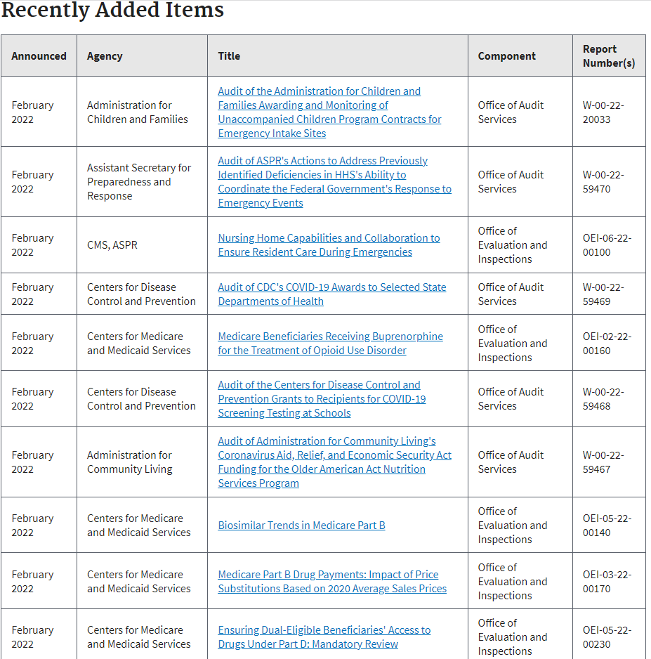

MPA recommends reviewing the recently added work plan items every month, determining if any items are relevant to your organization, and documenting your review and any audits or other compliance action items that are necessary.

OIG News
The OIG issued Advisory Opinion No. 22.04, involving a digital health company’s provision of access to digital contingency management and related tools to treat substance use disorders.
You can read the opinion here: https://oig.hhs.gov/documents/advisory-opinions/1024/AO-22-04.pdf
Department of Justice News
The Department of Justice appointed a Director for COVID-19 Fraud Enforcement, who will lead the DOJ’s effort to fight COVID-19 related fraud. Associate Deputy Attorney General Kevin Chambers will serve in this role.
https://www.justice.gov/opa/pr/justice-department-announces-director-covid-19-fraud-enforcement
State Enforcement
The California Attorney General arrested 14 people for their roles in a hospice fraud scheme that stole $4.2 million from Medicare and Medi-Cal (California Medicaid). The parties are accused of enrolling “patients who were not terminally ill into hospice care, many of whom told investigators that they were enrolled without their knowledge or understanding of what hospice was.”
https://oag.ca.gov/news/press-releases/attorney-general-bonta-announces-arrests-alleged-inland-empire-hospice-scam

The Wisconsin Attorney General entered a $2,050,000 settlement with Hayat Pharmacy to resolve allegations that the pharmacy billed Medicaid “for iodoquinol-hydrocortisone-aloe, topical cream, that was not medically necessary and/or dispensed without a valid prescription. On average, Hayat Pharmacy was reimbursed over $6,000 per tube of the topical cream. The government also alleged Hayat Pharmacy submitted claims to Medicare for Azesco, a multivitamin, that was not medically necessary and/or dispensed without a valid prescription. Hayat Pharmacy allegedly switched Medicaid and Medicare patients from lower cost medications to these medications.”
https://www.doj.state.wi.us/news-releases/ag-kaul-announces-2-million-agreement-hayat-pharmacy

L.A. Care, a publicly operated health plan, was fined $55 million by the California Department of Managed Health Care and the California Department of Health Care Services. The state regulators alleged that this action was necessary because L.A. Care’s violations “resulted in harm to its members…,” and stated: “Our investigations found several operational failures at L.A. Care, which have significantly impacted the health and safety of some of the state’s most vulnerable health care consumers.” Violations include handling of grievances, processing requests for authorization, and inadequate oversight and supervision of contracted entities.
https://www.dmhc.ca.gov/AbouttheDMHC/Newsroom/March4,2022.aspx

DOJ News
The Department of Justice announced that false claims act settlements and judgments exceeded $5.6 million in fiscal year 2021:
- This amount is the largest recovery since 2014 and the second largest recovery of all time.
- Over $5 billion of the recoveries related to health care.
https://www.justice.gov/opa/pr/justice-department-s-false-claims-act-settlements-and-judgments-exceed-56-billion-fiscal-year
White House News
The White house issued a FACT SHEET: Protecting Seniors and People with Disabilities by Improving Safety and Quality of Care in the Nation’s Nursing Homes. This Fact Sheet announces the President’s planned reforms to improve the quality of care in nursing homes. These reforms include:
- Promoting single-occupancy rooms
- Creating minimum staffing standards for nursing homes
- Proposing payment changes based on staffing, the resident experience, and staff retention
- Identifying “problematic diagnoses and refocus[ing] efforts to continue to bring down the inappropriate use of antipsychotic medications.”
- Increasing funding for surveys
- Overhauling the Special Focus Facility program
- Increasing financial penalties
- … and more.
https://www.whitehouse.gov/briefing-room/statements-releases/2022/02/28/fact-sheet-protecting-seniors-and-people-with-disabilities-by-improving-safety-and-quality-of-care-in-the-nations-nursing-homes/
OCR & HIPAA
OCR Director Lisa J. Pino posted a blog: Improving the Cybersecurity Posture of Healthcare in 2022. In this post, Pino lists some best practices for risk management (direct quote):
- Maintaining offline, encrypted backups of data and regularly test your backups;
- Conducting regular scans to identify and address vulnerabilities, especially those on internet-facing devices, to limit the attack surface;
- Regular patches and updates of software and Operating Systems; and
- Training your employees regarding phishing and other common IT attacks.
Pino also pointed to some OCR resources to boost cybersecurity (direct quote):
- Ransomware: https://www.hhs.gov/sites/default/files/RansomwareFactSheet.pdf - PDF
- Cybersecurity: https://www.hhs.gov/hipaa/for-professionals/security/guidance/cybersecurity/index.html
- Risk Analysis: https://www.hhs.gov/sites/default/files/ocr/privacy/hipaa/administrative/securityrule/rafinalguidancepdf.pdf - PDF
- HHS Security Risk Assessment Tool: https://www.healthit.gov/topic/privacy-security-and-hipaa/security-risk-assessment-tool.
https://www.hhs.gov/blog/2022/02/28/improving-cybersecurity-posture-healthcare-2022.html

HHS News
The HHS Cybersecurity Program issued a report: Electronic Medical Records in Healthcare. This report discusses why electronic health records are appealing to cyber threat actors, and how to protect EHR data. You can read the report here:
https://www.hhs.gov/sites/default/files/2022-02-17-1300-emr-in-healthcare-tlpwhite.pdf
OSHA News
OSHA continues to work on a permanent COVID-19 safety standard to replace the lapsed emergency standard.
https://news.bloomberglaw.com/safety/covid-19-regulation-still-on-agenda-osha-chief-doug-parker-says-1
OSHA announced an enforcement memorandum “for a short-term increase in highly focused inspections directed at hospitals and skilled nursing facilities that treat or handle COVID-19 patients.” This effort will involve focused inspections to monitor for “current and future readiness to protect workers from COVID-10.” Between March 9, 2022 and June 9, 2022, OSHA will “expand its presence in targeted high-hazard healthcare facilities….”
https://www.osha.gov/news/newsreleases/trade/03072022-0
OSHA issued a press release citing a “staggering 249 percent increase in injury and illness rates in 2020….” and calling on healthcare facilities and providers to “implement effective safety, health programs amid soaring injury rates.”
https://www.osha.gov/news/newsreleases/national/02172022

CISA News
CISA published a list of Free Cybersecurity Services and Tools designed to “help organizations further advance their security capabilities.”
You can see the list here: https://www.cisa.gov/free-cybersecurity-services-and-tools
CISA, FBI, and NSA, and international partners issued a joint Cybersecurity Advisory: 2021 Trends Show Increased Globalized Threat to Ransomware, which cites an “ongoing trend of growth in phishing, cybercriminal services for-hire and an increasing impact for ransomware group.” You can read about the ransomware trends here: https://www.cisa.gov/news/2022/02/09/cisa-fbi-nsa-and-international-partners-issue-advisory-ransomware-trends-2021
OCR & Civil Rights
The Office for Civil Rights published a Notice and Guidance on Gender Affirming Care, Civil Rights, and Patient Privacy. This notice and guidance clarifies that federal civil rights laws prohibit discrimination on the basis of sexual orientation and gender identity, and encourages parents or caregivers of children who have been denied health care such as gender affirming care to file a complaint with the OCR. Health care providers are encouraged to file a complaint with the OCR if they have been unlawfully restricted from providing such health care.
The notice also clarifies that HIPAA limits the circumstances when health care providers can disclose PHI about gender affirming health care – and that HIPAA “prohibits disclosure of gender affirming care that is PHI without an individuals’ consent except in limited circumstances.”
You can read the notice and guidance here: https://www.hhs.gov/sites/default/files/hhs-ocr-notice-and-guidance-gender-affirming-care.pdf

HIPAA & Social Media News

Settlements

Immediata Health Group agreed to a $1.13 million settlement to resolve a 2019 data breach that affected 1.6 million individuals. The lawsuit asserted that the clearinghouse did not adequately secure PHI.

https://healthitsecurity.com/news/inmediata-health-reaches-1.13m-settlement-after-2019-data-breach#:~:text=February%2014%2C%202022%20%2D%20Stemming%20from,protected%20health%20information%20(PHI).

State Enforcement

The New Jersey Attorney General entered a $130,000 settlement with two printing companies to resolve improper disclosures of PHI under HIPAA and the New Jersey Consumer Fraud Act. The companies “allegedly failed to safeguard sensitive information and disclosed the personal information and [PHI] of approximately 55,715 New Jersey residents.” The companies “failed to detect a printing error that affected explanation of benefits statements mailed to New Jersey residents from October 31, 2016, through November 2, 2016, and caused improper disclosure of [PHI] such as claims numbers, dates of service, provider and facility names, and the descriptions of services provided related to medical care received by these New Jersey residents.”

https://www.njoag.gov/acting-ag-bruck-reaches-settlement-with-two-printing-companies-over-improper-disclosures-of-protected-health-information/

Breach Roundup

Following are a selection of this month’s breach headlines from the news. We can’t possibly list all breaches – but please note that ransomware, unauthorized access to email, snooping, and late breach notification letters are trending.

Ransomware. An Illinois FQHC announced a data breach caused by a ransomware attack. https://familychc.com/data-breach-caused-by-ransomware-attack/

More ransomware. Extend Fertility notified individuals about a ransomware attack. https://extendfertility.com/wp-content/uploads/2022/02/Extend-Fertility-Notification-Website-Notice-.pdf

Email breach. Catholic Hospice notified patients that “email accounts for three Catholic Hospice employees may have been compromised.” https://www.catholichealthservices.org/news-catholic-hospice/notice-of-data-security-incident/

Late notification. Comprehensive Health Services of Florida “detected unusual activity within its digital environment following discovery of fraudulent wire transfers” on September 30, 2021. On November 3, 2021 – more than a year later – the company “learned that certain personal information may have been impacted in connection with the incident.” Notification letters were sent on January 20, 2922 and February 14, 2022 – more than a year after discovery. https://www.prnewswire.com/news-releases/notice-of-data-security-incident-301481106.html

Another late notification. Advocates, Inc., a Massachusetts non-profit healthcare provider, learned on October 1, 2021 “that Advocates data had been copied from its digital environment by an unauthorized actor.” It published notice of the breach on January 3, 2022. https://www.advocates.org/notice-data-security-incident#Notice%20of%20Data%20Security%20Incident

Yet another late notification. Business associate Morley Companies announced on February 2, 2022, “a data security incident that may have impacted data….” “The incident began on August 1, 2021, when Morley’s data became unavailable… Morley learned that additional data may have been obtained from its digital environment.” https://www.morleynet.com/about/cyber-security-incident/

Yet another late notification. Suncoast Skin Solutions discovered on July 14, 2021 “that some of its systems were encrypted by an unknown party.” It concluded its investigation on October 14, 2021, and notified the public in early 2022. https://www.suncoastskin.com/data-security-incident-notice/

Business associate breach. Billing company (and business associate) Medical Healthcare Solutions, Inc. “experienced a cyber-incident that impacted some protected health information (PHI) within its network.” https://www.medicalhealthcaresolutions.com/notice-of-cyber-incident/

Snooping. OSHU announced that “an employee may have inappropriately viewed a small number of patients’ limited health information involving prior hospital admissions. The information included: the patient’s name, reference to their location during their hospital stay and limited medical information.” This occurred between January 2019 and December 2021. https://news.ohsu.edu/2021/12/14/ohsu-breach-notification-6858625

More snooping. Michigan Medicine notified 269 patients that “a newly-hired employee accessed patient medical records without a business need” between 12/1/2021 and 1/25/2022. https://www.uofmhealth.org/michigan-medicine-notifies-patients-data-information-breach

COVID-19 test results breach. The Houston Health Department announced “a breach of health information in its COVID-19 test results portal… Approximately 3,500 portal users potentially had access to approximately 10,000 COVID-19 test results….” https://www.houstontx.gov/health/NewsReleases/houston-health-department-provides-notification-of-health-data-exposure.html

Features

Earn CEUs with MPA's FREE Compliance & HIPAA Webinars!
By Margaret Scavotto, JD, CHC

Sign up for MPA's FREE Compliance & HIPAA webinars:
All webinars are 11:00 a.m. CST - 12:00 p.m. CST and are presented by Margaret Scavotto and Scott Gima.

April 6, 2022: Compliance Lessons from Ted Lasso
1.2 CCB CEUs
“Taking on a challenge is a lot like riding a horse, isn’t it?”
"You know what the happiest animal on Earth is? It's a goldfish. You know why? It's got a 10-second memory."
"If the Internet has taught us anything, it's that sometimes it's easier to speak our minds anonymously."

Ted Lasso, the Apple TV series that has earned a host of Emmys and Golden Globes, has become a household staple. For most of us, it’s a 29-minute mental break when our work is done for the day. But America’s favorite soccer coach also brings us some priceless compliance lessons. Leading a compliance program through and beyond a pandemic isn’t too different from leading a downtrodden soccer team in England: it’s challenging and requires continuous sources of motivation.
SIGN UP

May 11, 2022: Affordable Care Act Compliance Programs for Nursing Homes
1.2 CCB CEUs
It’s been a long road since the Affordable Care Act mandated compliance and ethics programs for nursing homes in 2010. Since then, we have had rules issued; enforcement delayed; and a pandemic. Compliance is never easy in the highly regulated world of long-term care – but it has only gotten harder since this mandate was announced.
SIGN UP
The Compliance Certification Board (CCB)® has approved this event for up to 1.2 live CCB CEUs based on a 50-minute hour. Continuing Education Units are awarded based on individual attendance records. Granting of prior approval in no way constitutes endorsement by CCB of this event content or of the event sponsor.

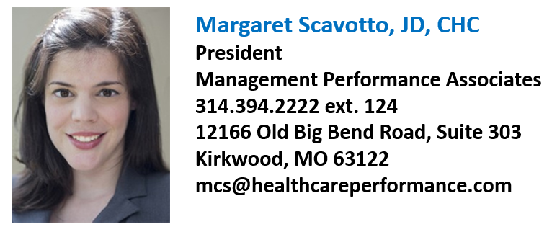
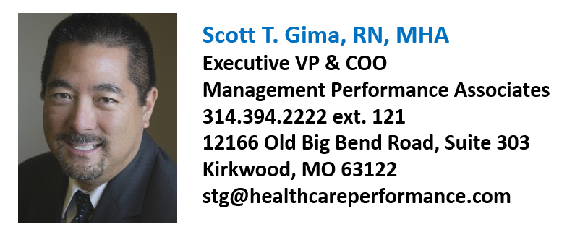
Note: This newsletter contains examples of news, updates, and enforcements from the last month – it does not contain all news, updates, or enforcements that came out the last month. MPA’s newsletter does not constitute legal advice.

